SCOTCH COLLEGE YEAR 11
WAVES TEST 2016
Time = 50 mins Total Marks = [50 marks]
NAME:

Question 1 (2 marks)

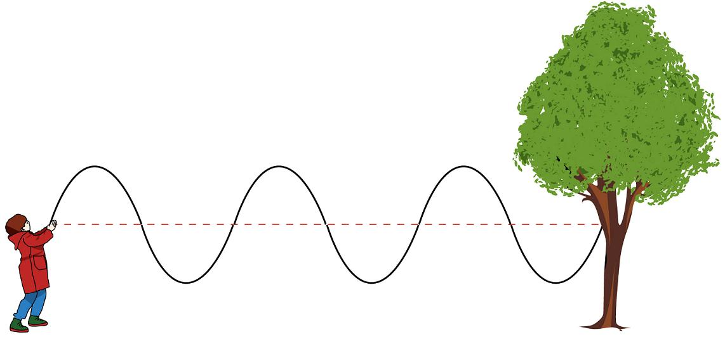
You can make a wave move along a piece of rope by moving one end up and down. At a particular instant, the shape of such a rope is as shown in the diagram. Estimate the amplitude and wavelength of the wave moving along the rope. (no explanation required)

Amplitude: ___________

Wavelength: ___________

Question 2 (2 marks)
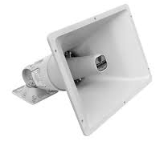
A diffraction horn is a special type of loudspeaker that is designed to produce a wide spread of sound into a listening area. Using your knowledge of diffraction suggest how this type of loudspeaker is able to produce a wider spread of sound.

Question 3 (9 marks)

There are a number of statements below, some which refer to standing waves only (S), some which refer to travelling waves only (T) and some which are common to both wave types (B). Complete the table below by inserting tick in the appropriate cells. If the statement does not apply, then leave the cell blank.

STATEMENT | Properties of
 | S | T | B
No energy is transferred.
All oscillations have the same amplitude.
Energy is transferred through the medium.
All oscillations have the same frequency.
Amplitude varies with position.
All oscillations have a different frequency.
Wavelength is twice the distance between adjacent nodes
Wavelength is the shortest distance between two points in phase.
Oscillations between adjacent nodes are in phase.
Oscillations one wavelength apart are in phase.

Question 4 (2 marks)

Calculate the wavelength in air of a high-pitched sound of frequency 3250 Hz if the speed of sound in air is 340 ms⁻¹.

Question 5 (4 marks)

(a) Briefly explain why a middle C on a sax sounds different to a middle C on a piano?

(b) What Physics terminology (word) best describes Pitch and Loudness?

Pitch: _______________ Loudness: ________________

Question 6 (5 marks)
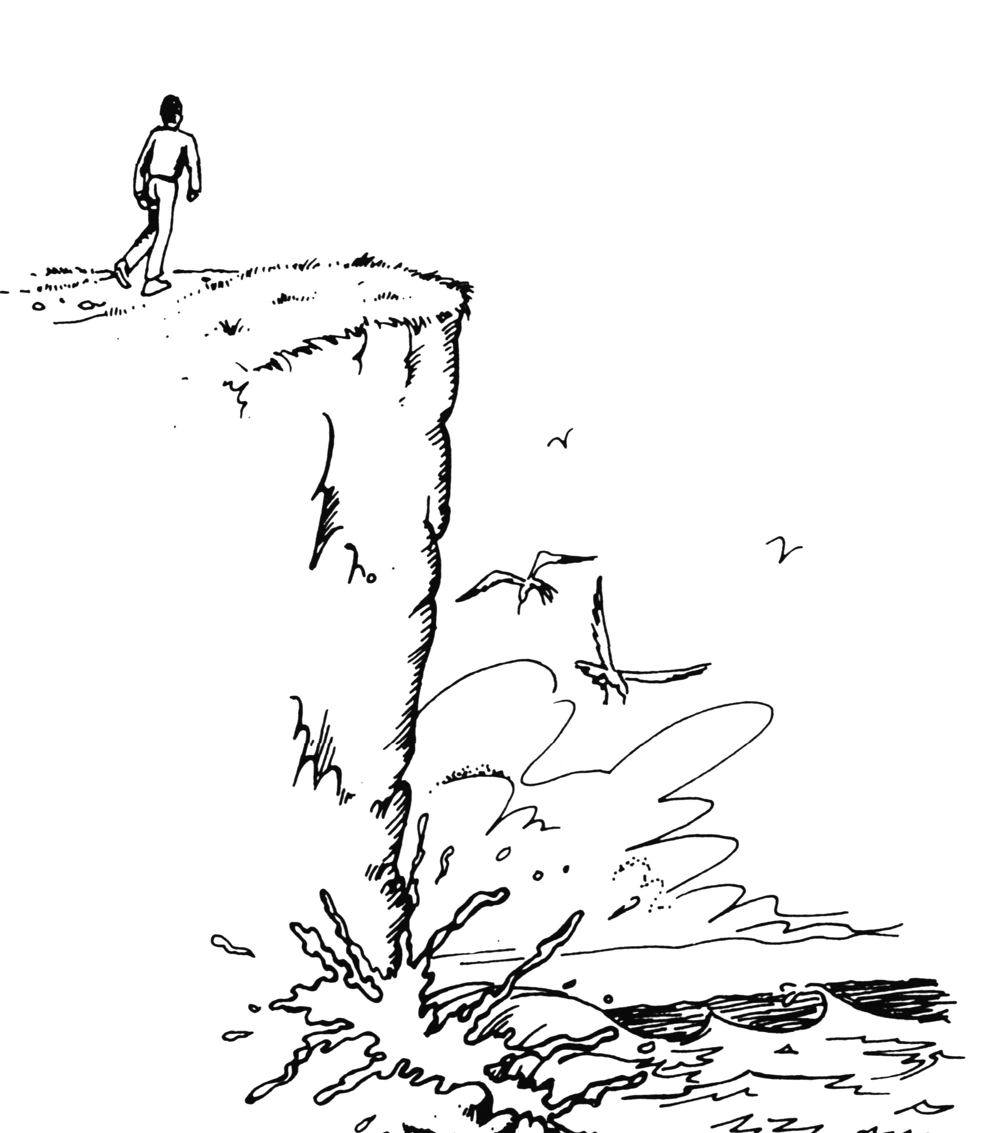
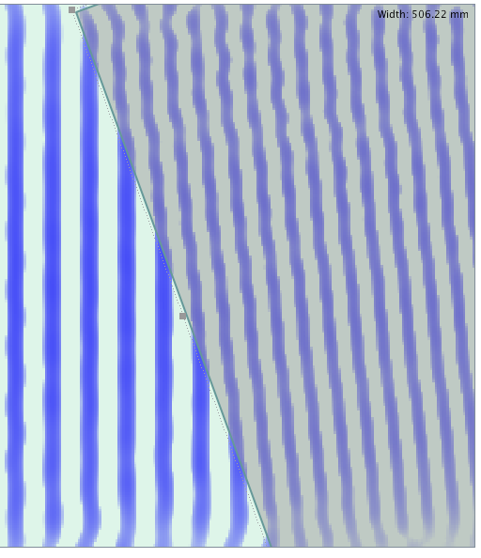
- You are walking along a path on a cliff about a surf beach. The path is not quite on the cliff edge, so you cannot actually see the surf, nor can you see the seagulls that are flying below the cliff.
Explain why you can hear the pounding of the surf, but you cannot see the seagulls.
- The diagram at the right shows a series of wave crests transitioning from deep water to shallower water.
i). Does the wave speed up or slow down when it enters shallow water?

ii). What wave behaviour is illustrated in the diagram?
DEEP WATER SHALLOW WATER
iii). What property of the wave is unchanged as it enters the shallow water?

Question 7 (7 marks)

Tom and Carlin connect two speakers (labeled A and B) to a single frequency wave generator in order to investigate the loudness of the sound produced at different points in the Science laboratory. The speakers are 3.00 m apart and Tom stands at a position D, which is exactly midway between the speakers and at a perpendicular distance from them. Carlin is standing at position C, which is directly in front of speaker A, 3.00 m from it and directly in line with Tom.

- Draw a diagram that shows the situation described above.
- If Tom starts to walk directly towards Carlin, in what way will the sound that he hears vary? Explain.
- In his position, Carlin hears a very soft sound. Determine the minimum frequency of the sound being emitted by the two speakers (assume that the speed of sound is 340 ms⁻¹).

Question 8 (5 marks)

The picture below shows the resultant of two waves, WAVE 1 (shown) and WAVE 2 (not shown). Study the picture carefully, and answer the questions that follow.
WAVE 1
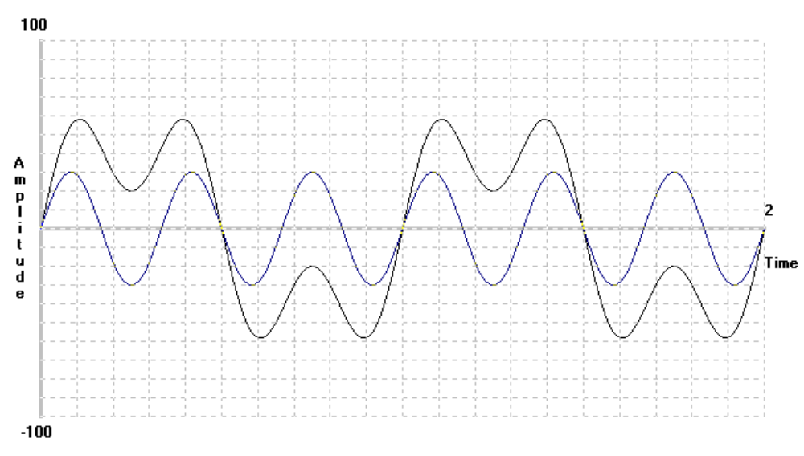
RESULTANT

a) Sketch WAVE 2, so that the resultant of WAVE 1 and WAVE 2 is as shown above.

b) Complete the following information about WAVE 1, WAVE 2 and the RESULTANT

 | WAVE 1 | WAVE 2 | RESULTANT
AMPLITUDE
FREQUENCY
PERIOD

c) Label with a “C” all points of maximum constructive interference.
Label with a “D” all points of maximum destructive interference

Question 9 (5 marks)
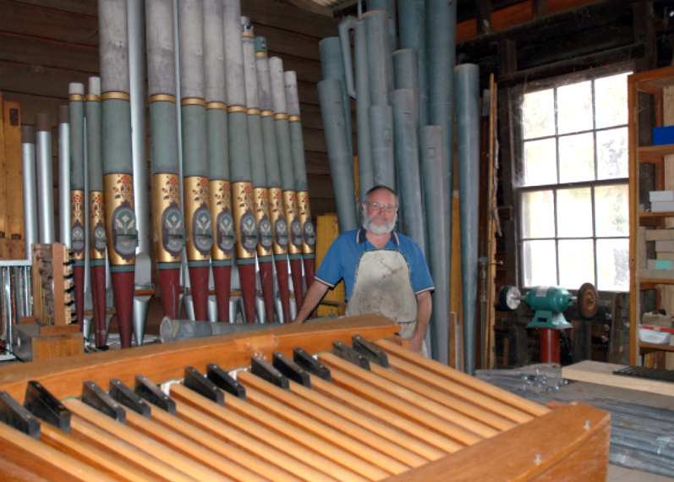
Figure 1: Organ builder John Larner has this week spoken to The eRecord following the tragic loss of his home and livelihood in the Yarloop and Waroona fires
An organ pipe, such as that shown at right is open at both ends and has a second harmonic of 228 Hz.
- What is the length of this pipe?
- What is the frequency of the third harmonic for this pipe?
- What is the wavelength of the fourth harmonic for this pipe?
- Suggest one advantage of using organ pipes that are closed at one end, rather than open at both ends.

Question 10 (7 marks)

Metal girders (beams) are often used in buildings that have been constructed to withstand earthquakes.
To aid the design of these buildings, experiments are undertaken to measure how the natural
frequency f of horizontal oscillations of metal girders varies with their dimensions. In an
experiment, f was measured for vertically supported girders of the same cross-sectional area
but with different heights h.

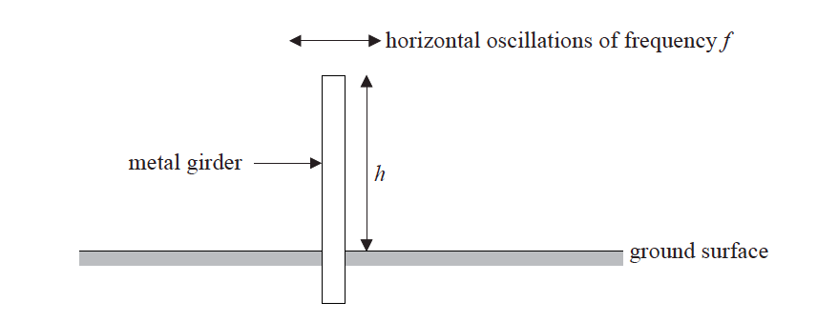

The graph below shows the plotted data for this experiment.
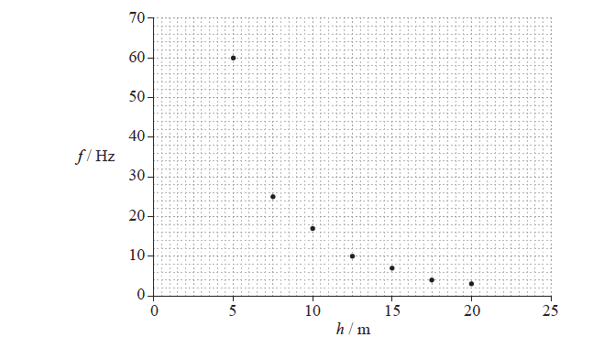

- Draw a best-fit line for the data.
- It is hypothesized that the frequency f is inversely proportional to the height h.
By choosing two well separated points on the best-fit line that you have drawn in (a),
show that this hypothesis is incorrect.
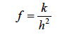
b) Another suggestion is that the relationship between f and h is of the form shown below,
where k is a constant.

The graph below shows a plot of f against 1/h².

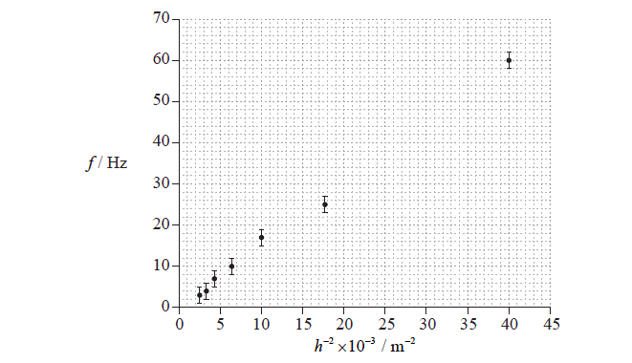

c) Draw a best-fit line for the data that supports the relationship and determine, using the graph, the constant k.

